Memory Game Instructions

Object of game – Match a Pair of cards

How to Play

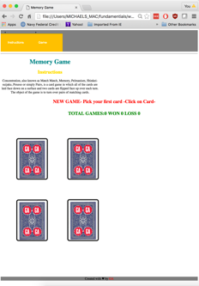

Start by clicking on web page and clicking one of the 4 displayed cards. Feel free to pick any card. They were randomly shuffled up to 100 times so each game will be a challenge!

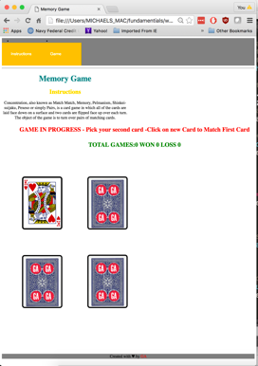

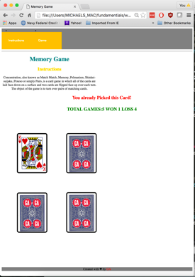

Once you select the first card the card is flipped over to reveal the card. You next task is guess what other card will match the card by number or picture – Obviously it will be of a different suit. Remember not to pick the same card TWICE! That would be cheating!

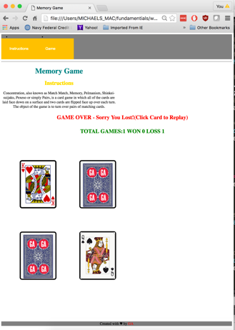

You better be Lucky! The odds of picking a match are not in your favor. You have a one I 3 chance.

Oh.. I’m sorry you did not get a match, but Try again by clicking on any card to reset the game.

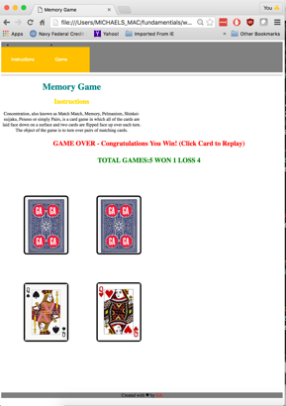

FINALLY- a winner! Good Luck and have fun!